Детские вопросы и как на них отвечать

[](https://2.bp.blogspot.com/-JTvEMoVdIGk/W9dZnLJGP5I/AAAAAAAAAmw/7EXcpaPJZpgUvQWEZFyuR41C5G4N1RR3ACEwYBhgL/s1600/%25D0%25BF.jpg)

[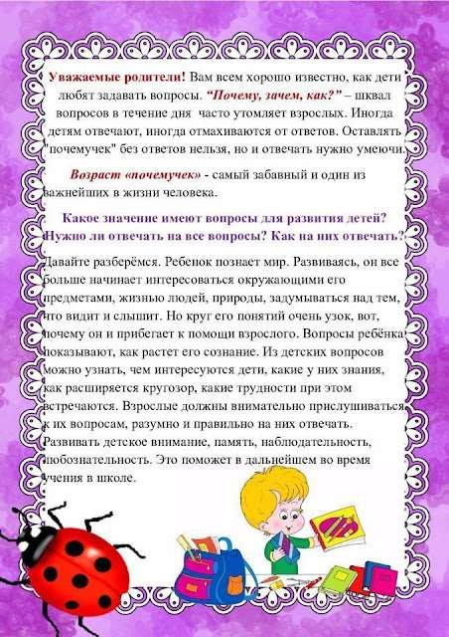](https://2.bp.blogspot.com/-yeJ2_GOst6E/W9dZmav2nsI/AAAAAAAAAmg/1j-JygRbkWM_cYgJ_wCtMEIROkpTZqCAwCEwYBhgL/s1600/TQniPkxkVrU.jpg)

[](https://1.bp.blogspot.com/-TCwJzOMjBx4/W9dZmQv0WdI/AAAAAAAAAmk/8_GwuLn1FYI5Y6SF6P-O2PMZXh9tpwL4ACEwYBhgL/s1600/LTSfLSetNrg.jpg)

[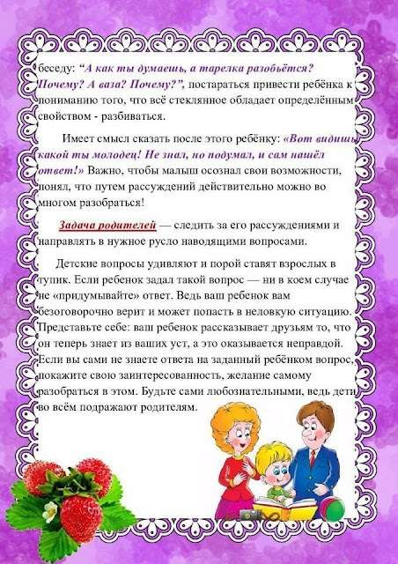](https://1.bp.blogspot.com/-lCJi__qcpYs/W9dZm4d9J-I/AAAAAAAAAm8/Y0Ni90U9RqcyLcI_UjfJ_uXF1kzPHuRPACEwYBhgL/s1600/oH_WuYsFPdg.jpg)

[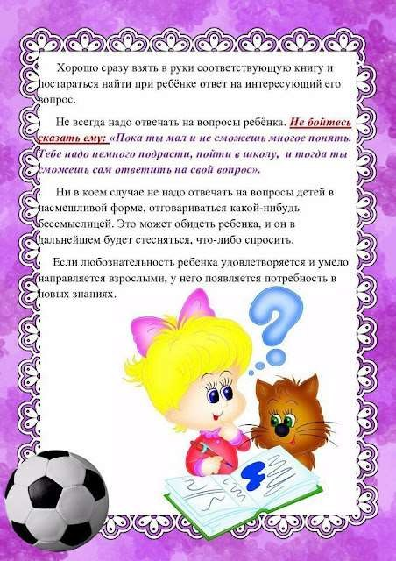](https://4.bp.blogspot.com/-6NBjDPH3Jqs/W9dZmZUJGCI/AAAAAAAAAm0/bBYgGeKvwrMS2tkHrFIOASYG8XUTmRFDQCEwYBhgL/s1600/54eNcSR3w7k.jpg)